Why do we need to host html/txt file to web browser?
We host HTML and TXT files on a web server so that they can be delivered over the internet and interpreted by a web browser.
This process enables users to view web pages and read text files remotely, regardless of their physical location

Login to AWS console
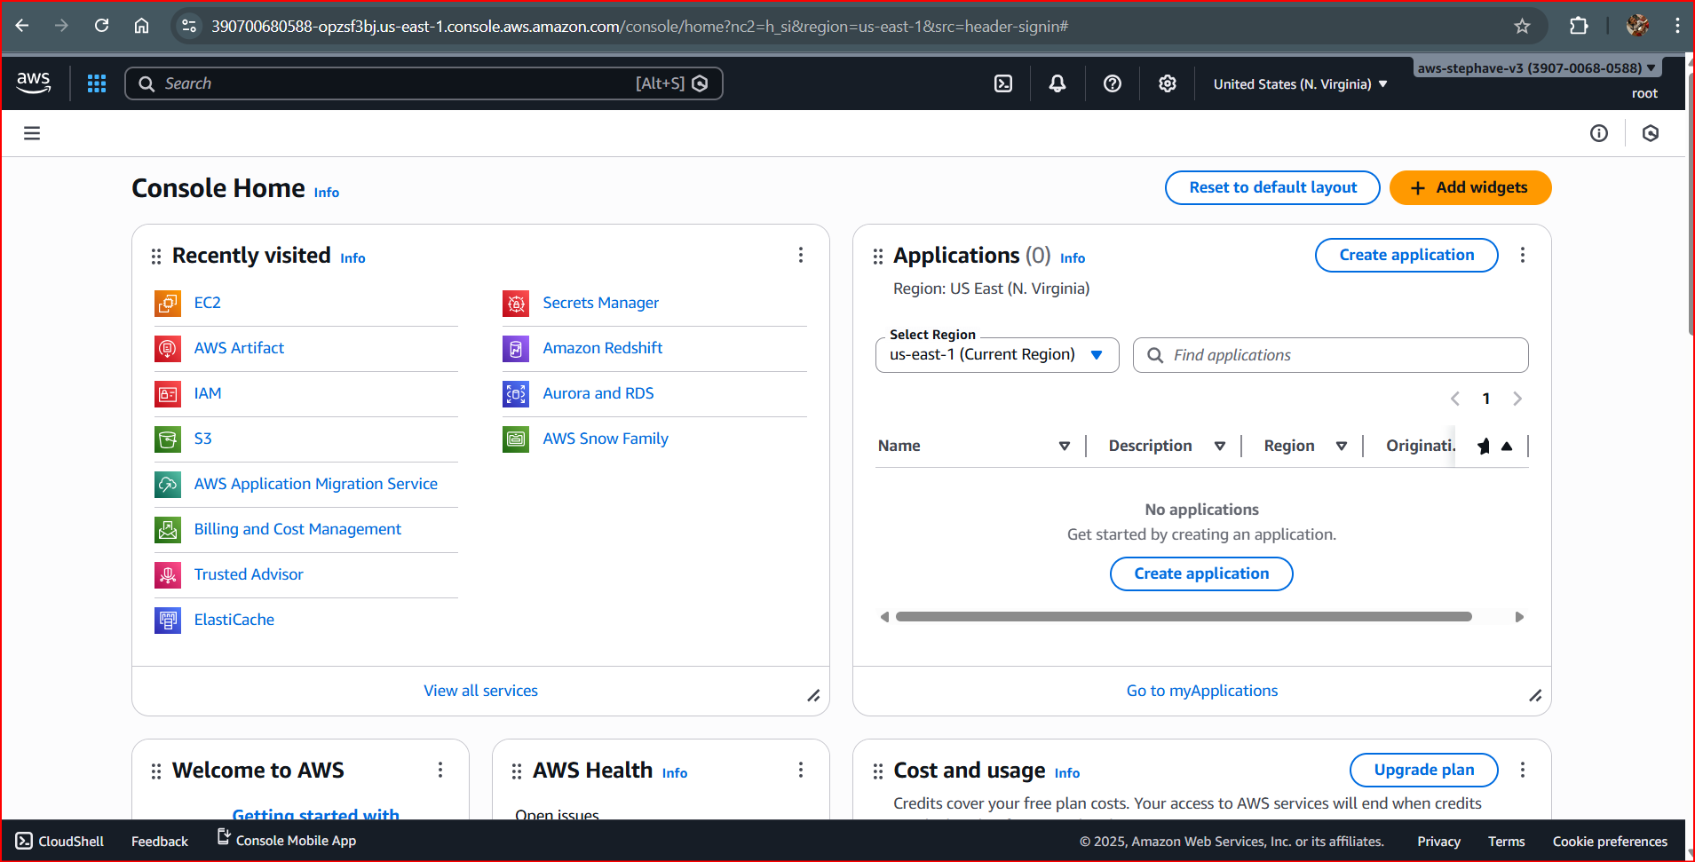
Select EC2 and click on Launch Instance
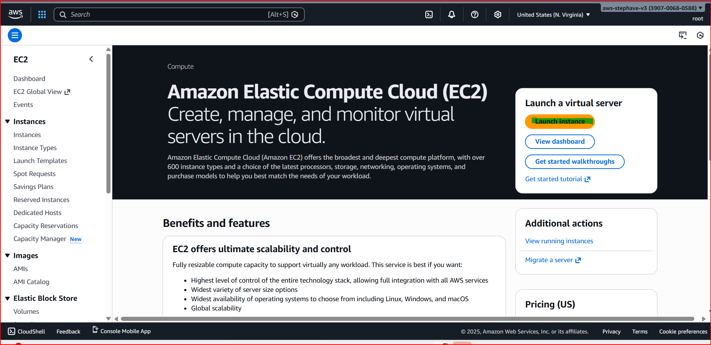
Give the name for your instance. Here we have named it as Chandan_Training

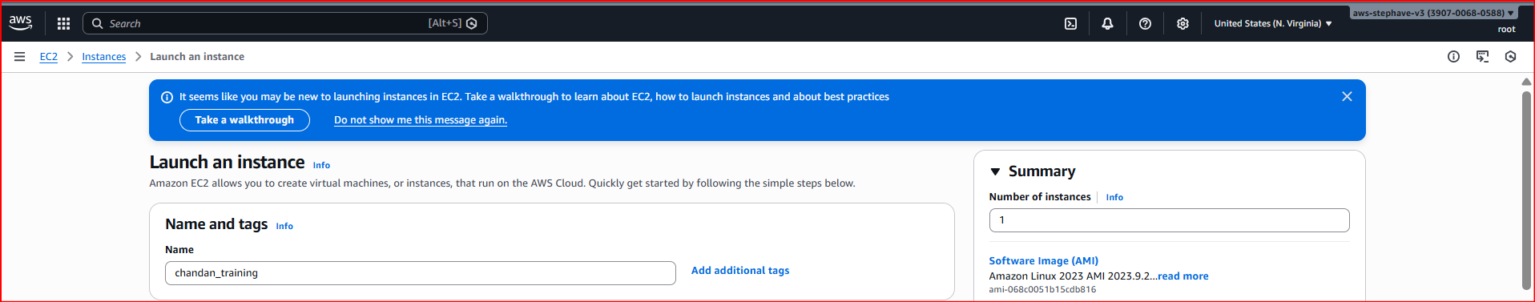

Select an operating system. For e.g select Amazon Linux.

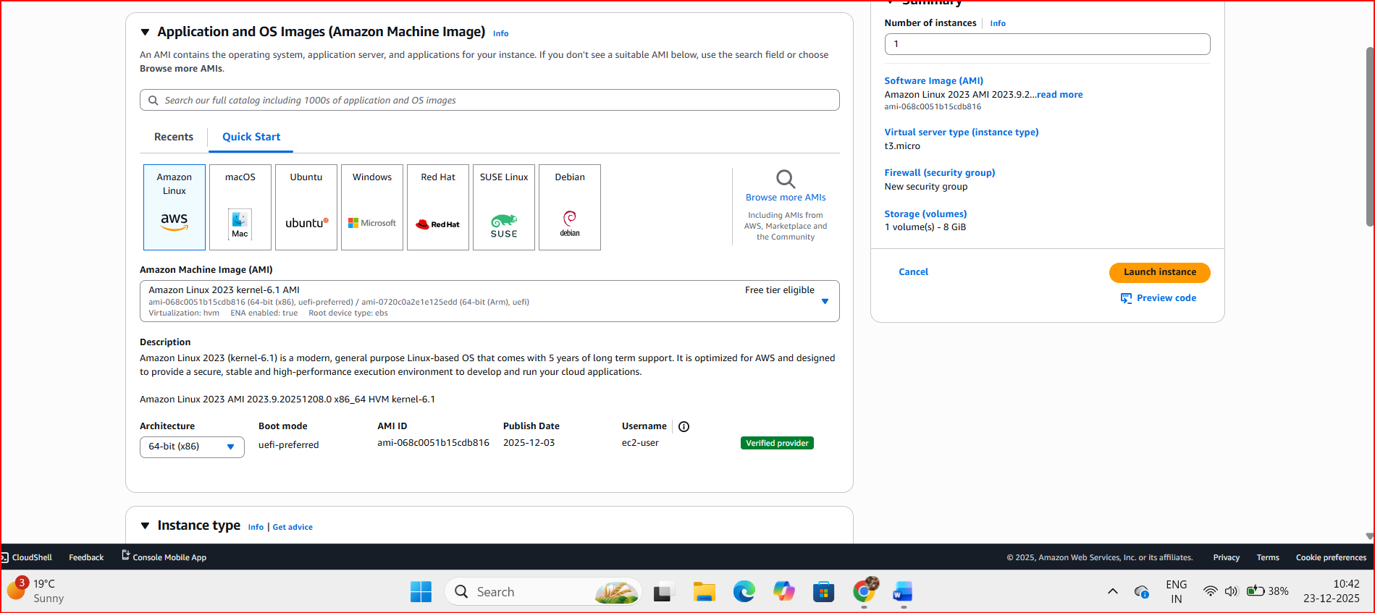

In instance type, Select t3.micro (Free tier eligible)

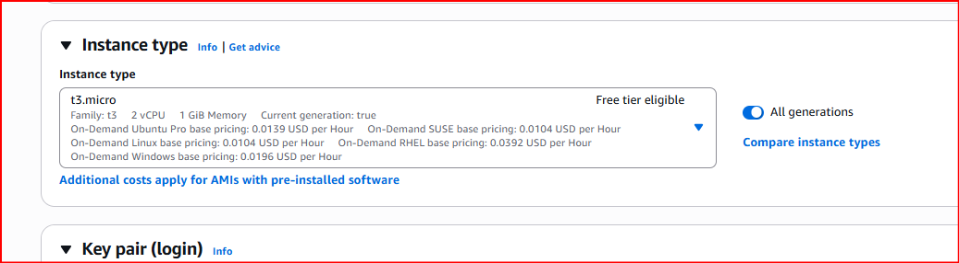

Click on Create Key pair
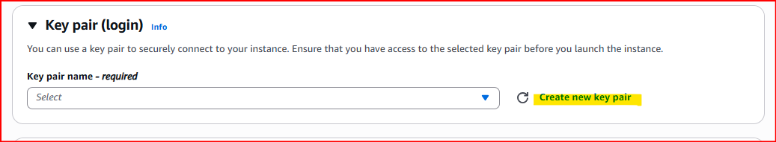

Enter keypair name which you can easily remember->key pair type- keypair file format. For this one I have selected .pem and click on create key pair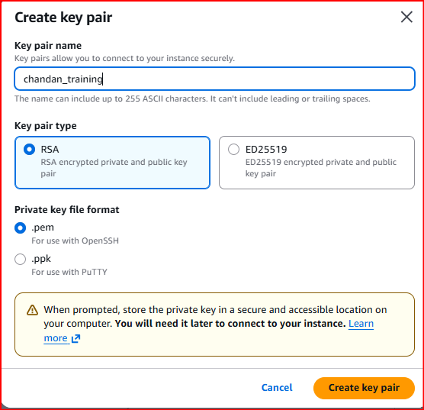

Key get generated and save it on your drive folder. Key pair get saved.
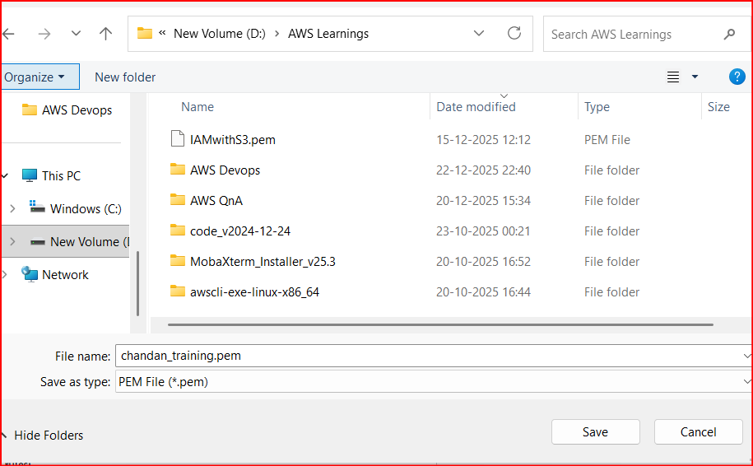

Network Setting
You can enable all ports for learning purpose where port allowed traffic
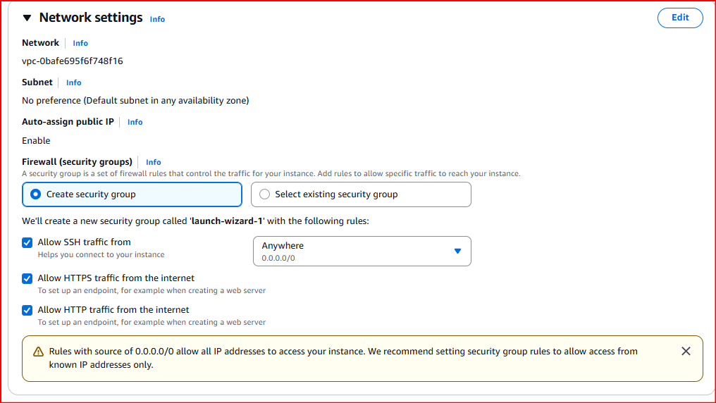
Note:- Security group either you can create new or select existing group if available.
[AWS Security Groups are virtual firewalls for EC2 instances, controlling inbound/outbound traffic via stateful rules (allow by default for responses) based on protocol, port, and source/destination]

Storage Configuration
Storage configuration in AWS EC2 involves choosing from several options to meet different requirements for persistence, performance, and scalability. The primary storage types are Amazon Elastic Block Store (EBS) and Instance Store, which can be complemented by other AWS storage services like Amazon S3, EFS, and FSx.
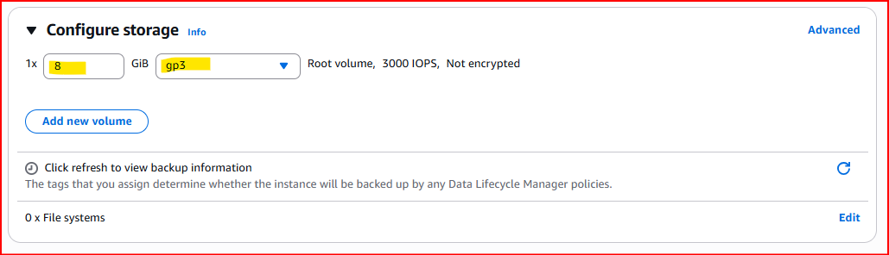

Click on Launch Instance
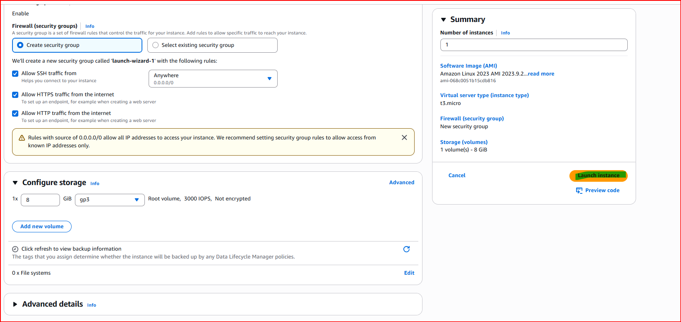

To verify instance status go EC2-> View All Instances -> You will be able to see your new instance.

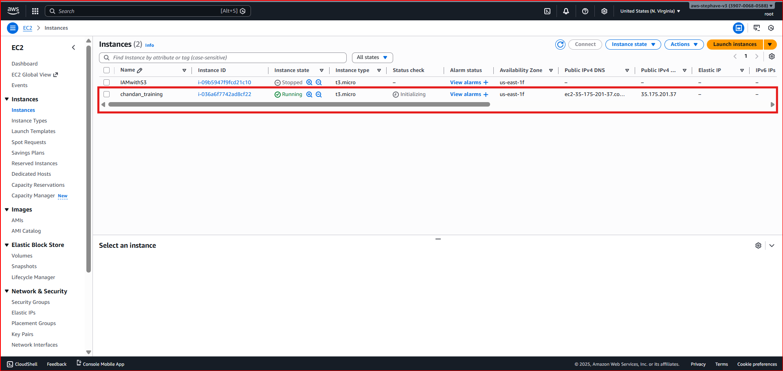

Select the instance and details will show where you can get the Public and Private IP address and other details related to your instance.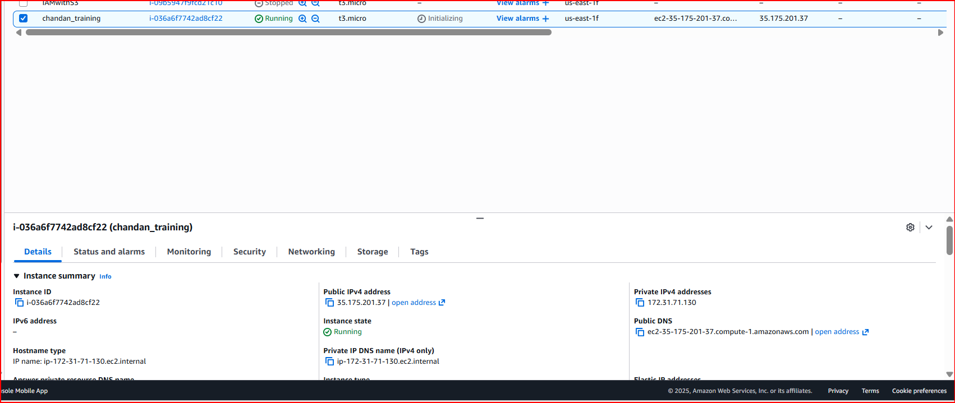

Get Public IP or DNS name to connect it through internet. Also note the Instance Id to connect through CLI.

Download PuTTy through https://www.putty.org and install it. In your task bar of your local system, search for PuTTygen and select it. PuTTygen dialogue box appears, then select Load option. Search for the key pair file which would be in the .pem format and open it.

Click on “Load”, make file type as “All Files”, select the downloaded .pem file to convert it to .ppk file, and click on “Save private key”.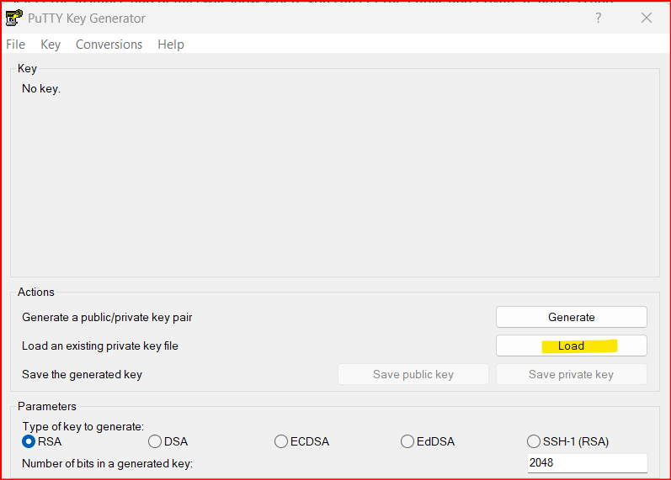

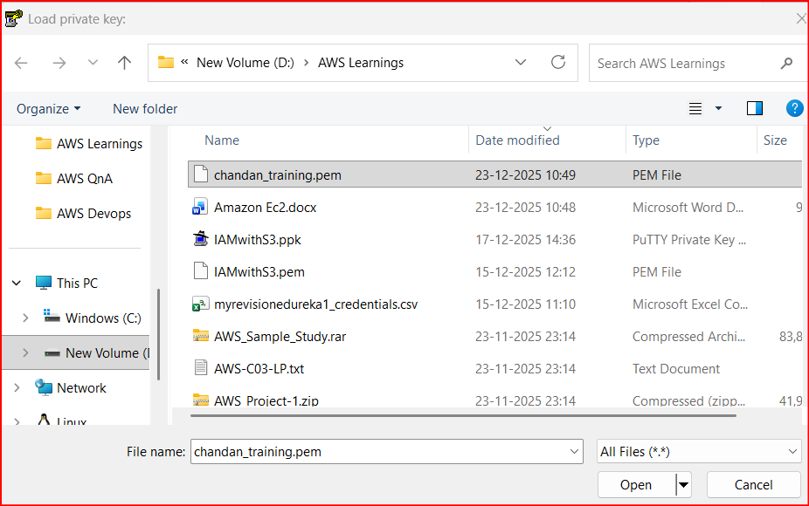
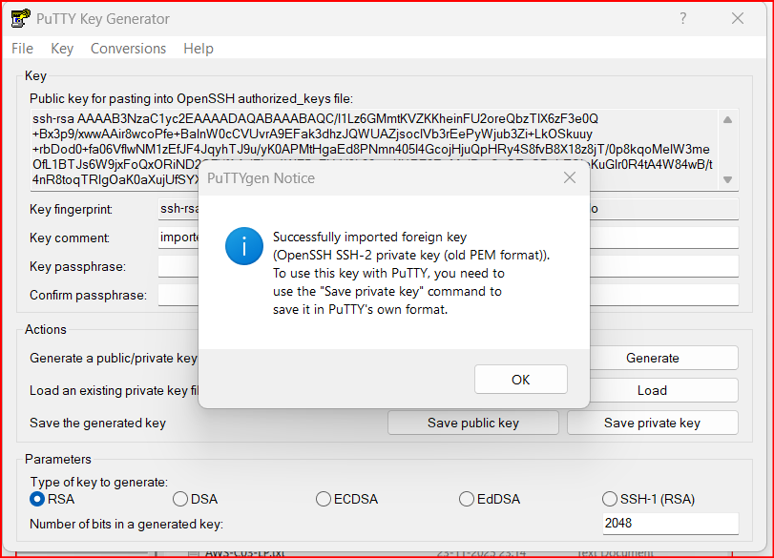
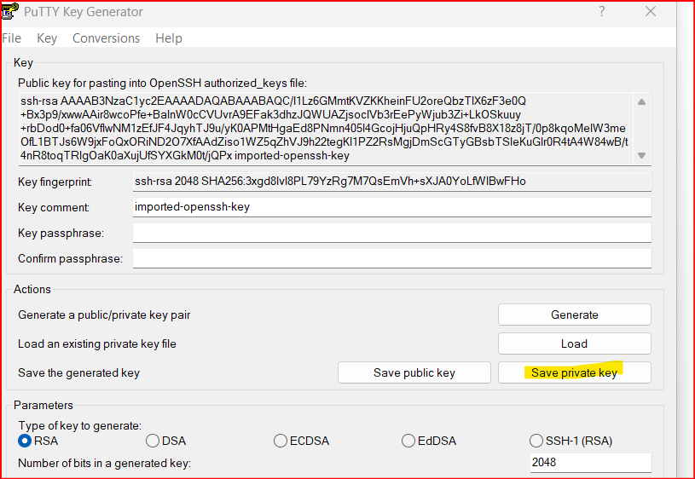

While saving the key change the file extension name from .pem to .ppk and key will be saved in .ppk format
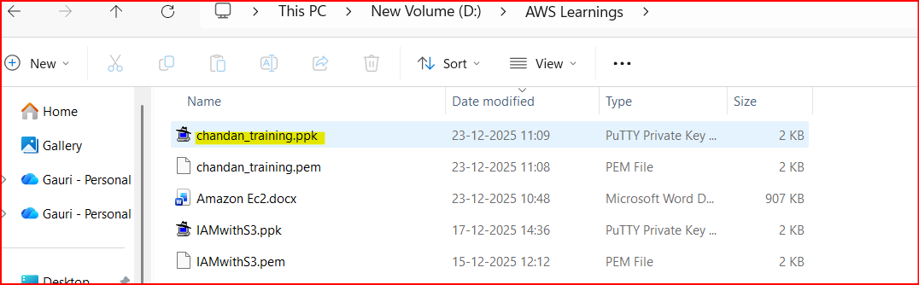

Now we are going to connect the EC2 instance through SSH. For this first copy the DNS name or Public IP.

Open he Putty app and paste the copied Instance DNS/ IP address in Host name.
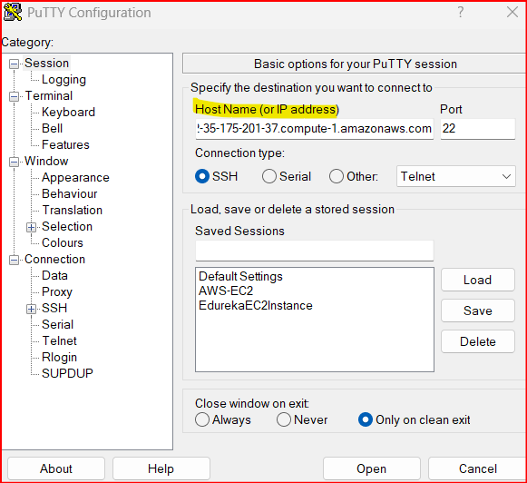

Click on highlighted SSH-> AUTH-> Credential-> Browse private key-> Click to Open
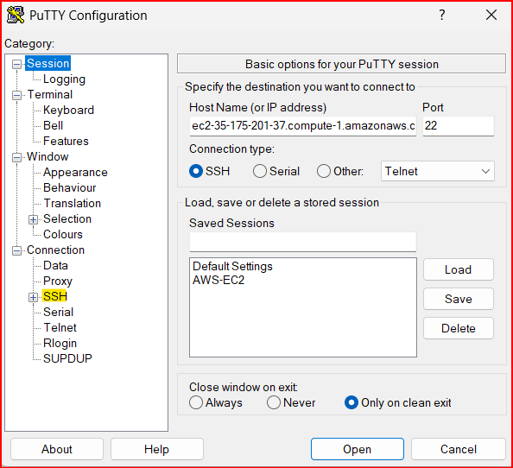
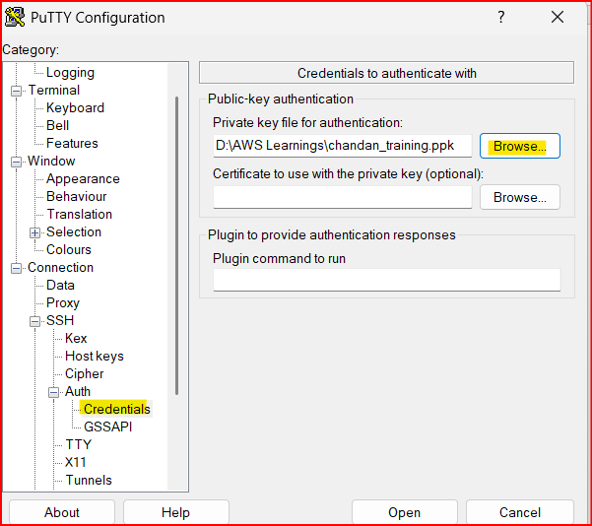

Below termial will open
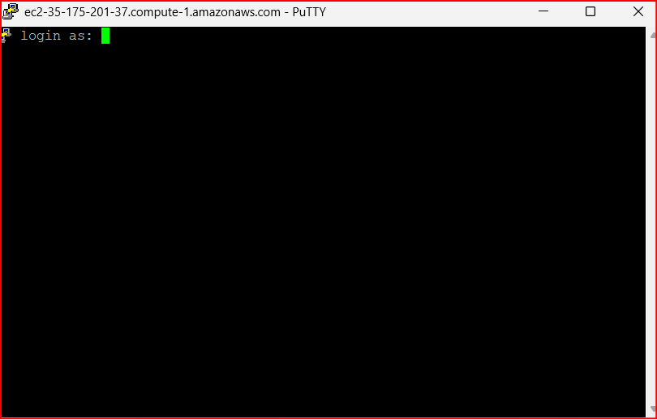
To login and start working with your instance type the User Name of instance. For Amazon Linux user will be ec2-user and for ubuntu user name will be ubuntu
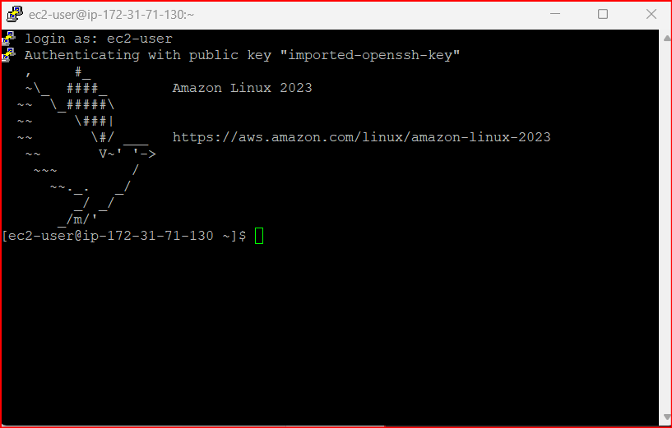

To get your user name you can click on connect 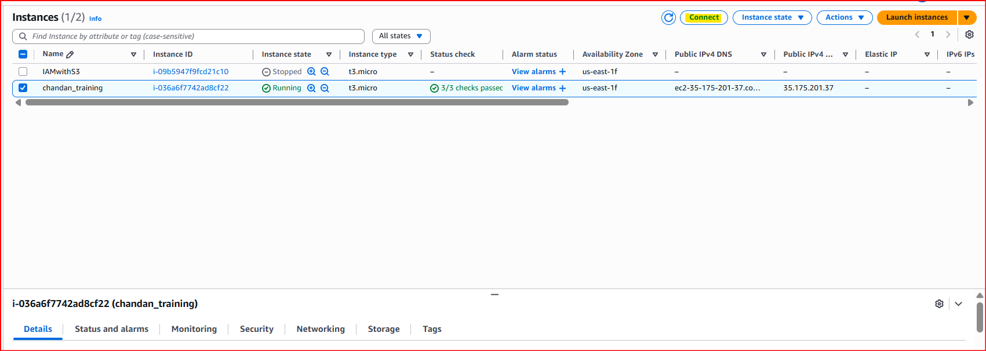

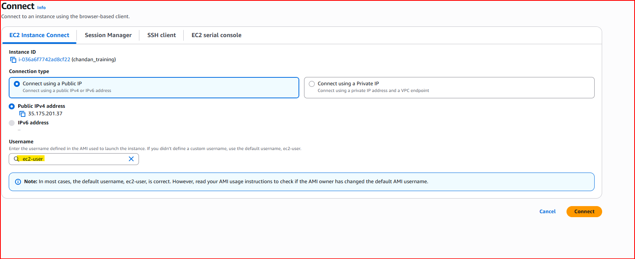

We have successfully connected to our Amazon Linux Instance using SSH

Now I followed the same and launched a ubuntu instance and able to login via SSH.

NOW we need to install the apache server in our Ubuntu instance. For this enter the below command
Sudo apt update 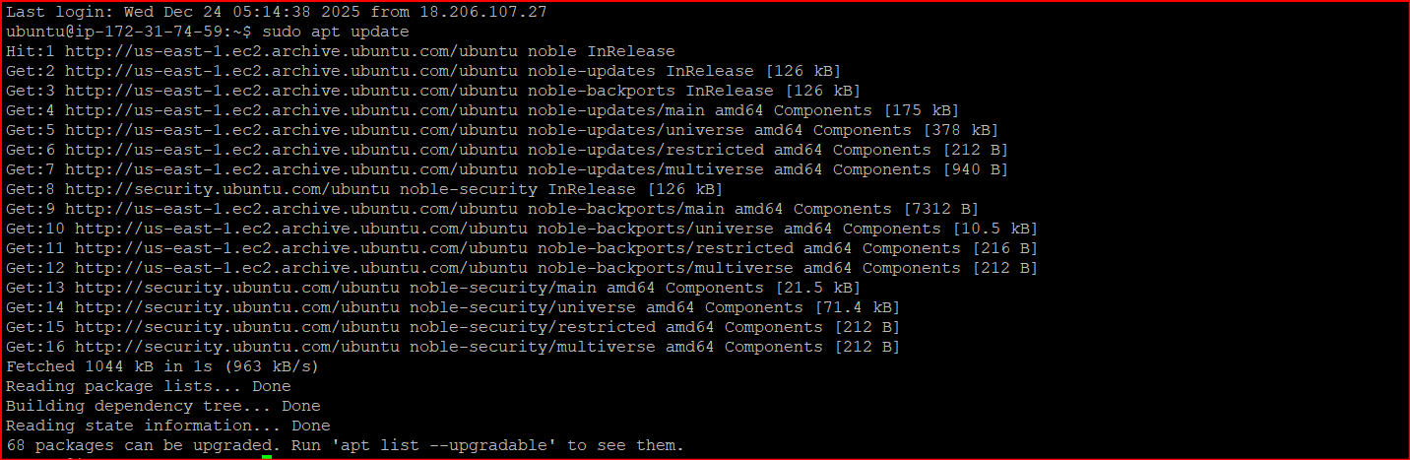
sudo apt install apache2
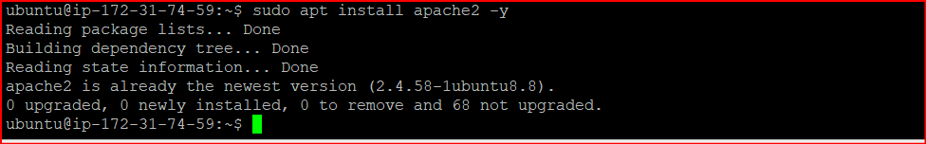

Start Apache
sudo systemctl start apache2
sudo systemctl enable apache2

Check
sudo systemctl status apache2
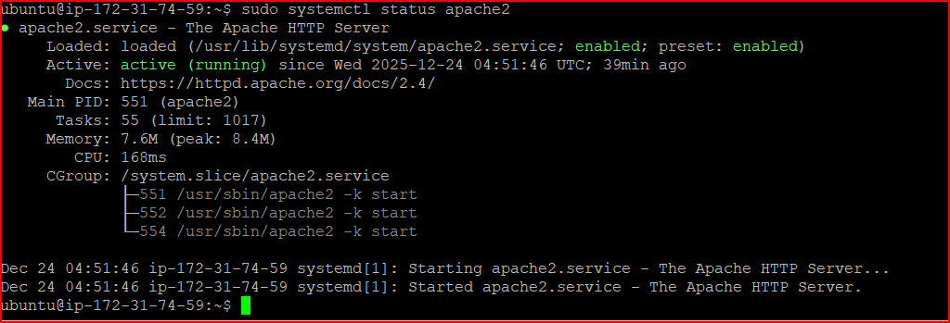
To check apache server is running enter this url into your browser
http://Public IP address:80

Note:- Public IP address is your EC2 ip address

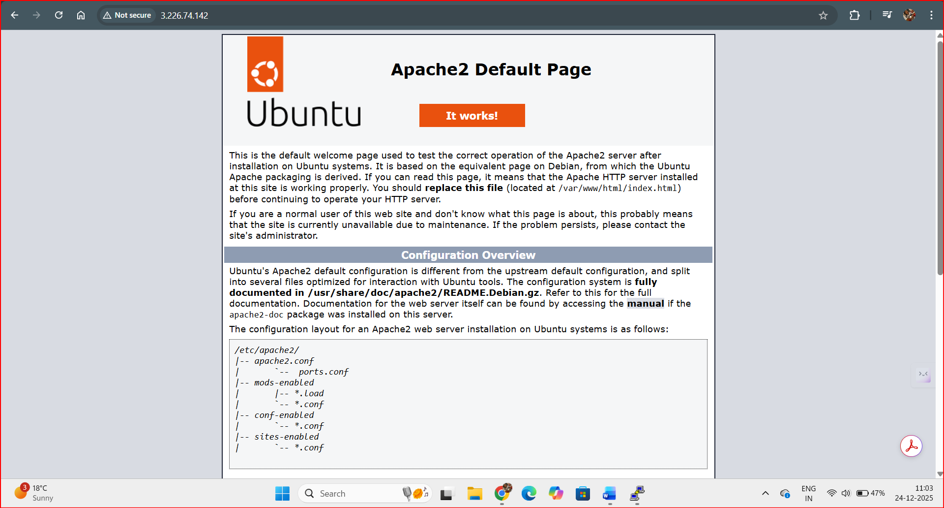

Go to website folder
This is the only folder Apache reads by default:
cd /var/www/html
Create your first website file
The default website file is:
index.html

Create and open it in vim:
Create a directory I have given the folder name Chandan
mkdir Chandan
Where it was created: In your home directory

creating a new folder on your computer
cd chandan/
Create a Text file :- vim hello.txt
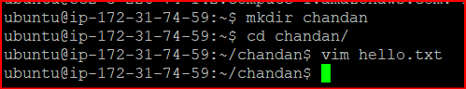
pressed i to go into INSERT mode
Enter the comments and save
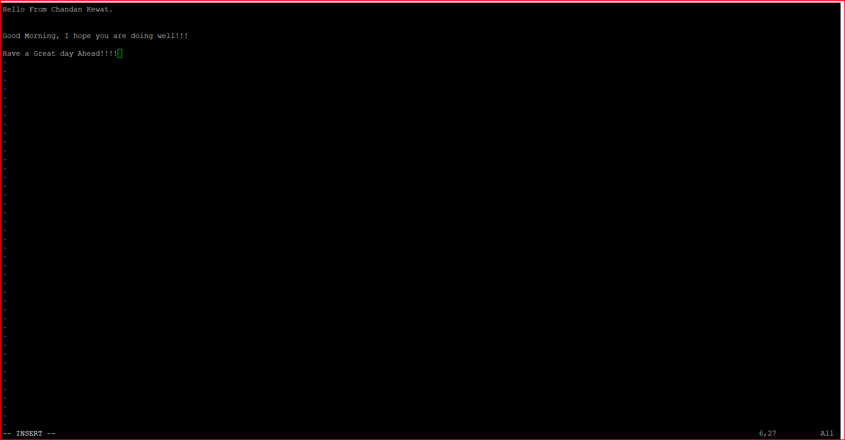
Press ESC to exit from insert mode.
To save and quit type :wq and hit enter.

File get saved in your folder
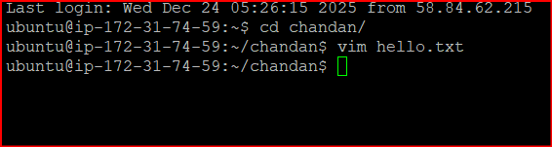

Find where your text file is saved
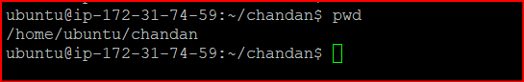
Text file name
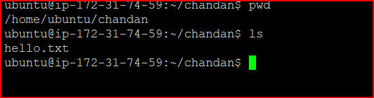
Move the text file to Apache web directory
Apache only serves files from /var/www/html.
Run
sudo mv /home/ubuntu/myfolder/test.txt /var/www/html/
Now the file is in the correct web location.

Set correct permissions (VERY IMPORTANT)
Apache must be able to read the file.
Verify Apache is running
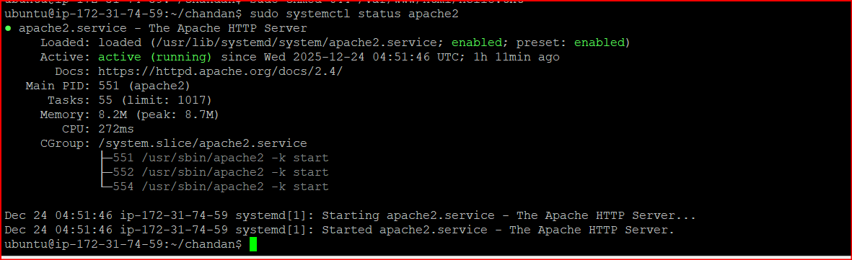
Get your server’s Public IP
curl ifconfig.me

Open the text file in browser
Now open any browser and type:
http:// 3.226.74.142/hello.txt

(Important for EC2) Check Security Group
If page doesn’t open:
- Go to AWS EC2 → Security Groups
- Edit Inbound Rules
- Ensure this exists:
Type | Port | Source
HTTP | 80 | 0.0.0.0/0
Steps to check if a web browser is running
Sudo lsof -I -P -n | grep LISTEN
Check the file permission also by - sudo chmod 644 /var/www/html/hello.txt

If all inbound rule of the security group are as expected and file permission given then below is the result you will get.

